E-form Internal System
Table of Contents

1. Home Page 3
1.1 Create Project 3
1.2 Project Actions 5
2 BOM Management Page 7
2.1 BOM Item 7
2.2 Import BOM items through Excel 8
3. Request For Quotation (RFQ) 10
3.1 Understand RFQ Flows 10
3.2 Create RFQ 11
3.3 Additional features 12
3.3.1 Merging Multiple RFQ 12
3.3.2 Import Data to RFQ(For Buyer only) 13
4. RFQ Tracker Page 14
4.1 RFQ Tracker 14
5. Purchase Request (PR) 15
5.1 Understand PR Flows 15
5.2 Create PR 15
5.3 PR Approval Page 16
6. PO Tracker Page 18
6.1 PO List tab 18
6.1.1 Edit: 19
6.1.1.1 Submit PO 19
6.1.1.2 Reject PO 20
6.1.2 Delete: 21
6.2 PO History tab 21
6.2.1 Export Excel 22
7. Receiving Tracker 23
7.2 Receiving Tracker – Item Listing Page 26
7.2.1 Normal Flow 26
7.1.2 Partial Received 29
7.1.3 Partial Item Issue Out 29
8. History Page 32

1. Home Page

1.1 Create Project
1) Certain user groups start with the  button to create a new project. Specific user groups refer to Sales, PM, HOD, GFC and CEO.

2) Enter the project details to the corresponding field in the pop-up form.
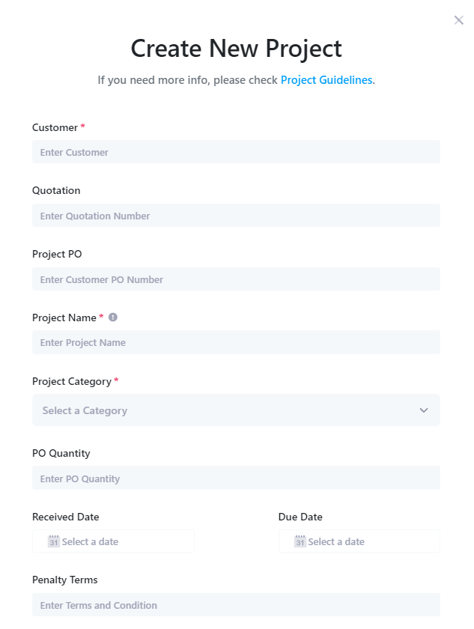
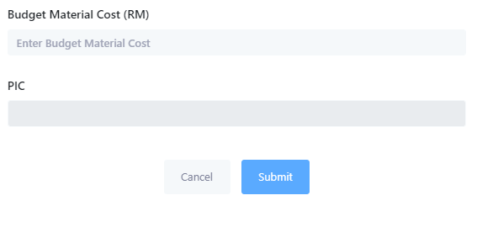

3) Click on the PIC field and assign employees to the project in the pop-up list. Allocators can choose a leader among the PICs. The selected leader will have the same ability to dispatch employees to the project as the assignor. Click to confirm the initial assignee.
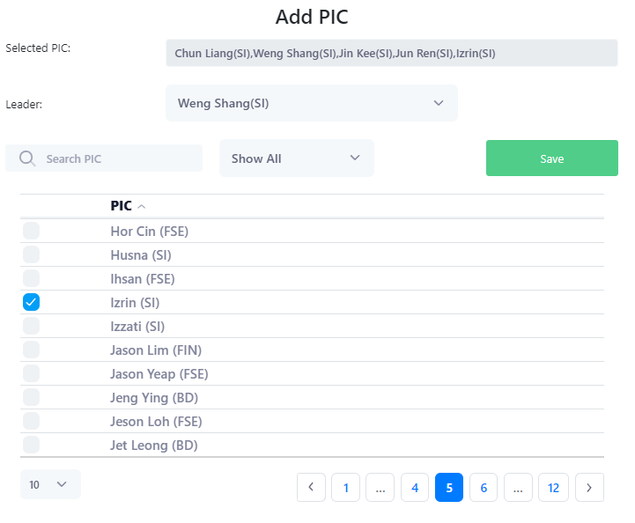
Figure 1 Pics Form
4) After confirming that all the information for the project is correct, click the  button to create the project.

5) The project table is divided into two tabs. As you can see in the image below, 'All Project' will list all projects, while 'My Project' will only list projects for which the current user is one of the assignors.
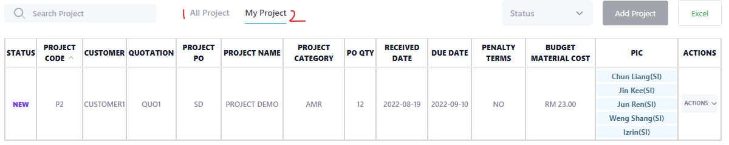
Figure 2 Project Table

1.2 Project Actions

1) The permission user group for modifying a project is the same as for creating a project. Edit and Delete options are invisible to ordinary users.
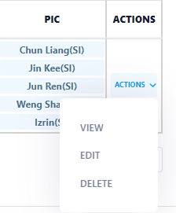
Figure 3 Project Actions

2) Similarly, after clicking the Edit button, the user only needs to modify the information in the pop-up project form and click the submit button to complete the action of updating the project information.

3) The following figure shows the notification after clicking the delete action.
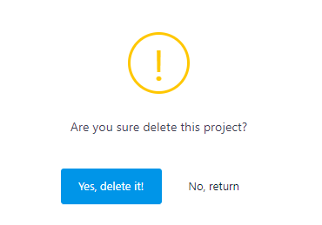
Figure 4 Delete Project Alert

4) By clicking on the PICs column of the corresponding project, users with permissions can adjust the Pics of the project.
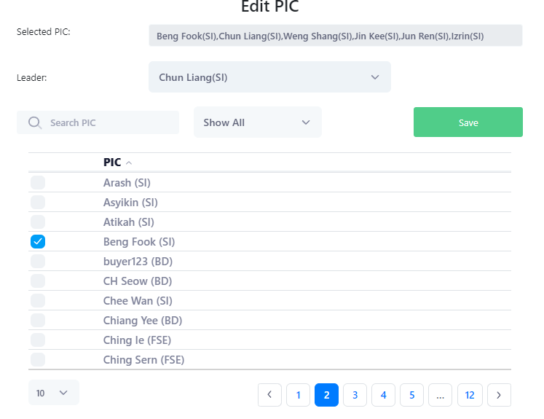
Figure 5 Edit PICs Form

2 BOM Management Page

2.1 BOM Item

1) In the corresponding project, execute the ‘View’ action.
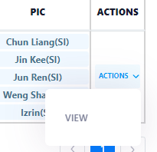
Figure 6 Project View Action

2) At the top right of the BOM table, click the  button. Note that only project assigners can create new BOM items.

3) Enter information into the corresponding fields in the BOM form. Complete the form and click the Submit button.
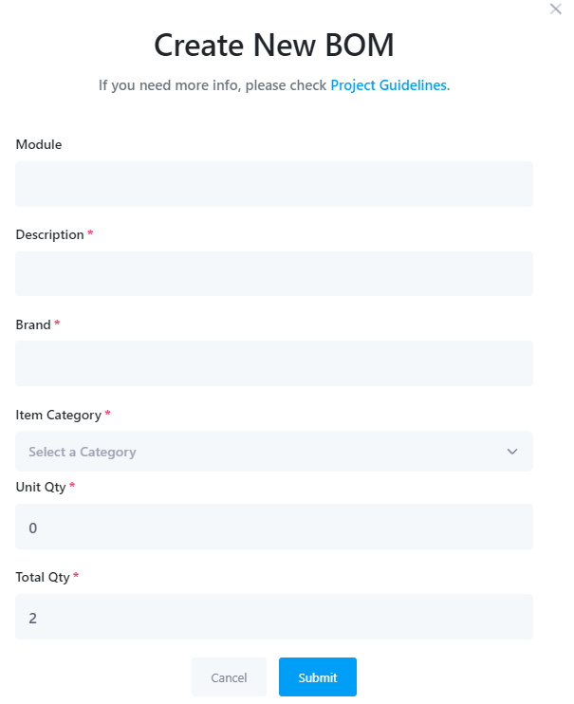
Figure 7 Add BOM Form
4) PICs can update or delete the specified BOM item in the action option.
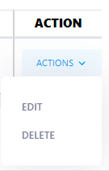
Figure 8 BOM Actions

2.2 Import BOM items through Excel

1) Click at the top right of the BOM.

2) Click the Download Template link to download the basic format of the Import BOM Table.
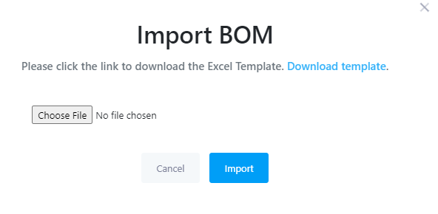
Figure 9 Import BOM Form

3) Enter information for any number of BOM items in the provided form.
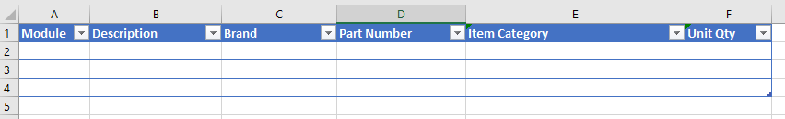

4) Save the Excel document. Then go back to the Import BOM form, select and upload the Excel document, and click the button.

3. Request For Quotation (RFQ)

3.1 Understand RFQ Flows
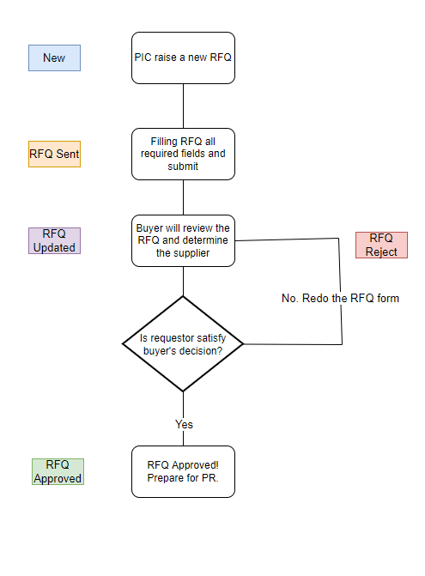
Figure 10 RFQ Flows

3.2 Create RFQ
1) In the RFQ column of the specified BOM item, click ‘CREATE RFQ’ button.
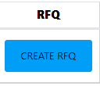
Figure 11 Create RFQ button

2) The RFQ form for each stage has different required information. If you see * in a specific field, it means that the field is a required field.
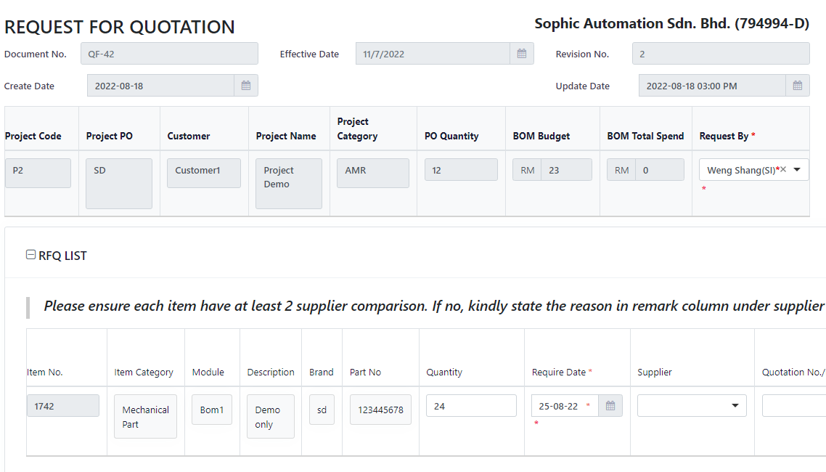
Figure 12 RFQ Form

3) At each stage, a specific user can perform different actions. For example, from the New state to the RFQ Sent state, the user can perform Save, Delete and Submit. In the RFQ Updated state, the requester can choose whether to accept the Buyer's proposal. Details of the RFQ process can be found in Figure 10.
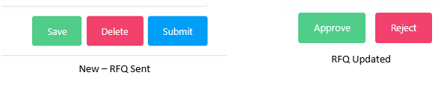
Figure 13 RFQ Actions

3.3 Additional features

3.3.1 Merging Multiple RFQ

1) PIC can combine an unlimited number of BOMs and create a shared RFQ Form. Merge by selecting the BOM items that need to be merged, and then clicking the xx button in the upper right corner.
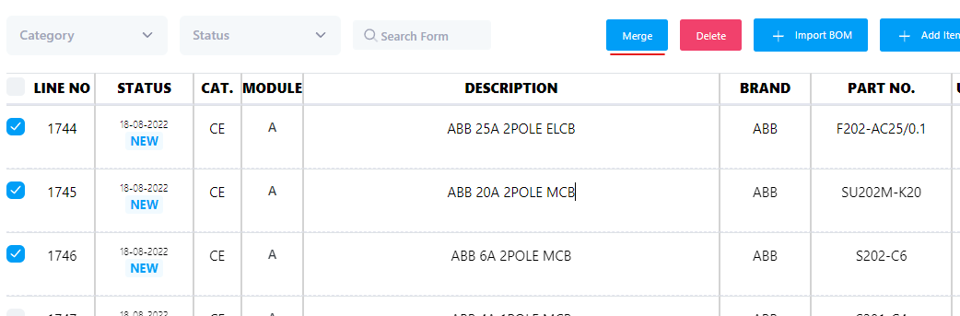
Figure 14 BOM Merge Action

2) The merge function has several conditions: the selected BOMs must all be New status, and the category of BOM items to be merged must be the same.

3.3.2 Import Data to RFQ(For Buyer only)

1) Click the 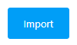 button in the upper right corner of the RFQ Page.
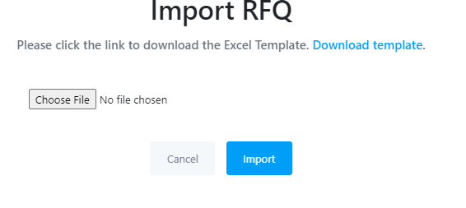
Figure 15 Import RFQ Form

2) Enter the information of the corresponding BOM item in the provided Excel sheet. The Item No must be the same as the BOM Item No listed in the RFQ form. Save the file when finished.
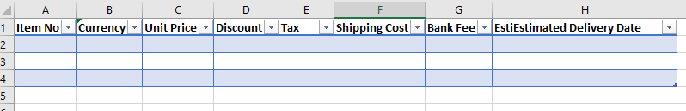
Figure 16 Import RFQ Excel Template

3) Go back to the Import RFQ form, select Upload Document, and click the button.

4. RFQ Tracker Page

4.1 RFQ Tracker

1) In the upper left menu, select RFQ Tracker and enter the page.
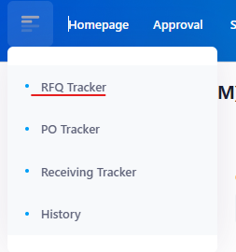
Figure 17 RFQ Tracker Option

2) This page will list all RFQ forms in progress.
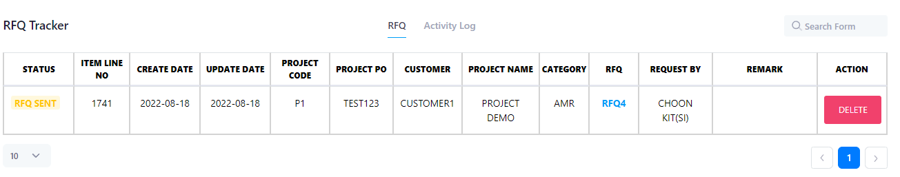
Figure 18 RFQ Tracker Page

3) Users can browse the details of all recent RFQ activities in the Activity Log.
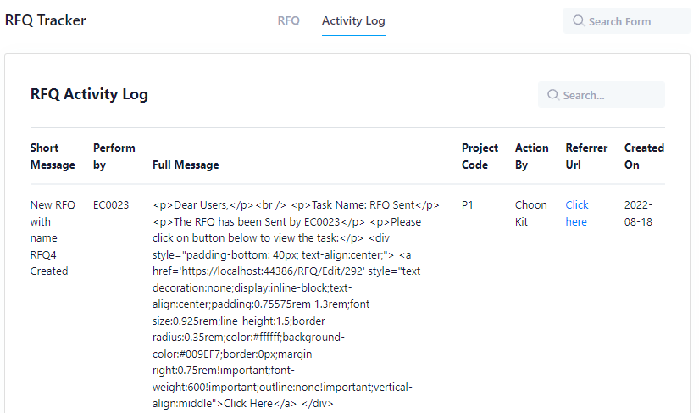
Figure 19 RFQ Tracker's Activity Log

5. Purchase Request (PR)

5.1 Understand PR Flows
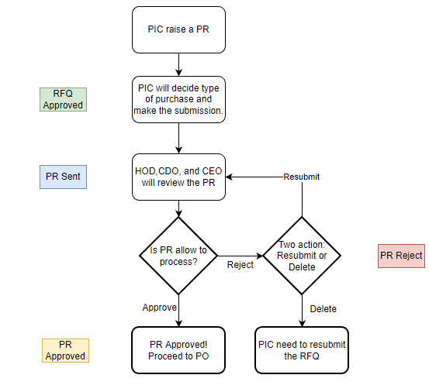
Figure 20 PR Flows

5.2 Create PR
1) When the PIC's RFQ is approved, the Create PR button will be activated. When the PIC's RFQ is approved, the Create PR button will be activated. Click on this button, the page will automatically turn to the PR form page.
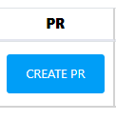
Figure 21 Create PR Button
2) Select a type of purchase, and then confirm that the PR form information is as expected, click to submit.
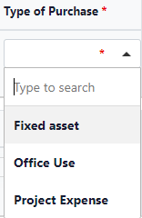
Figure 22 Types of Purchase

5.3 PR Approval Page
- To approve a PR form, it actually will have numerous of approver depend on the condition. For example, when the PR sub total price is lower than RM 10 000 then the PR form will only need one Approver with user type HOD to approve it. Please take note that only this form requestor’s department HOD can approve the PR form. If the sub total price is between RM 10 000 and RM 30 000 then it will need two approver which is HOD and GFC to approve it while if the sub total price is equal or over than RM 30 000 then it will need three approver which is HOD, GFC and CEO to approve the PR form.
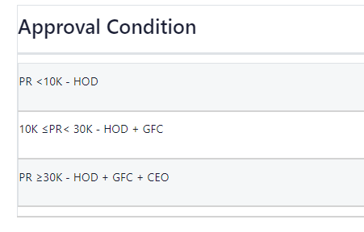
Figure 23 PR Approval Condition

2) HOD, GFC and CEO can view the number of PR forms that require their approval on the header page.
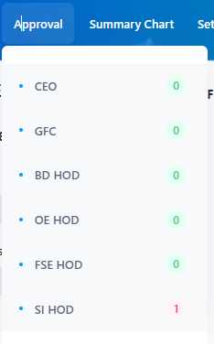
Figure 24 Page Header:Approval

3) HOD, GFC and CEO can click on the “Approve” and “Reject” button that locate at their respective box to approve/reject the form. Please take note that to approve the PR form, the approver needs to approve the form by sequence. For example, approver 2 cannot approve the form where the approver 1 is not approve the form yet. It must follow the sequence from approver 1 to approver 2 and then approver 3 in that order.
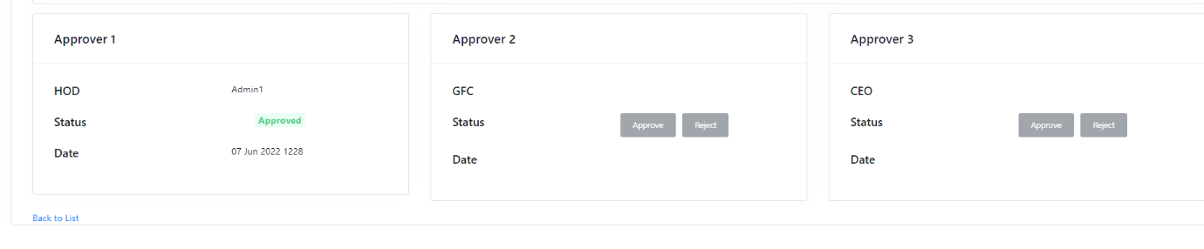
Figure 25 PR Approvers

6. PO Tracker Page
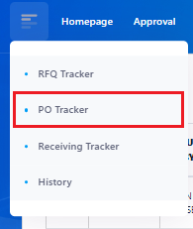
After the PR is being approved, the BOM will be showed in the PO Tracker page.
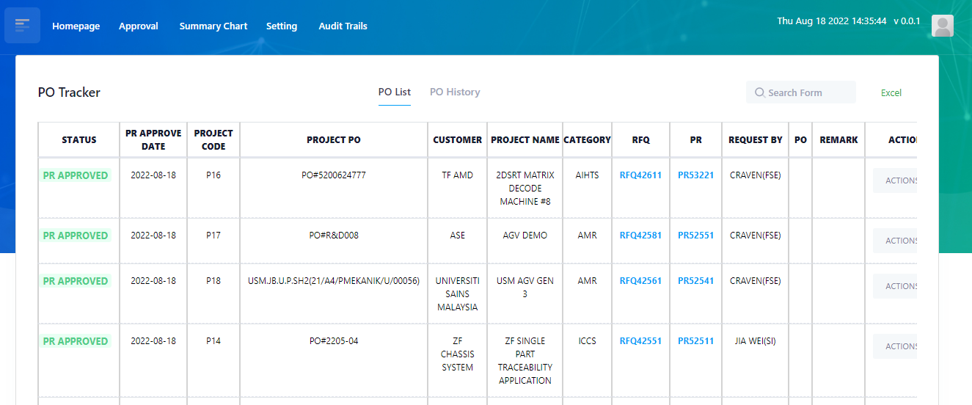

There are two tabs:
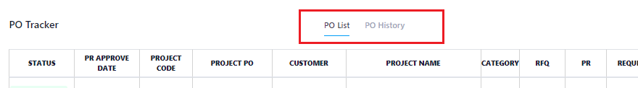

6.1 PO List tab
- BOM with status PR Approved, PO Approved and PO Reject will be display here.
- User can click on the RFQ number to view the particular RFQ form.
- User can click on the PR number to view the particular PR form.
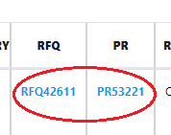

- Edit button at the right side of the table could perform Edit and Delete action.

6.1.1 Edit:
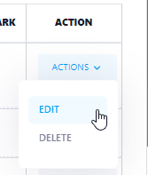

- Click on the Edit button, a pop up will display. Inside the pop up will show all the items within the PR along with the details.
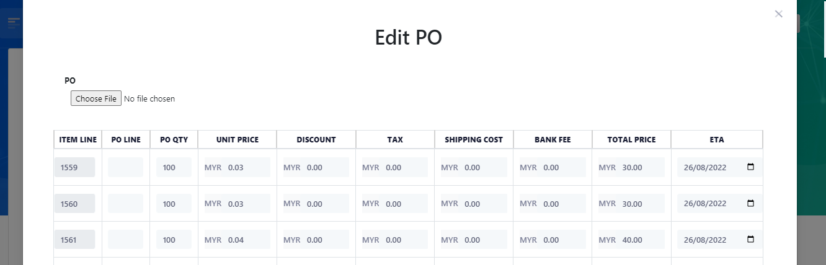

6.1.1.1 Submit PO
- User can upload the PO from the pop up by click on the ‘Choose File’ button located at the top-left of the pop up under the label PO.
- Note that only PDF format of file is allowed to upload.
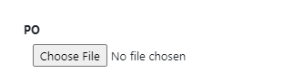
- Once the PO is uploaded, user will need to fill in the PO Line number for each item. User also can write a remark if wish to do so.
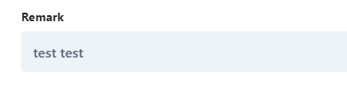
- If PO is uploaded and all PO Line number is filled for each item, click ‘Submit’ button to submit and the BOM status will be changed from PR Approved to PO Approved.

- The particular BOM will show in the Receiving Tracker page.

6.1.1.2 Reject PO
- Alternatively, user can reject the PO by click on the ‘Reject’ button.
- Upon clicking, a pop up will showed. User will be requested to write a remark of why reject the PO.

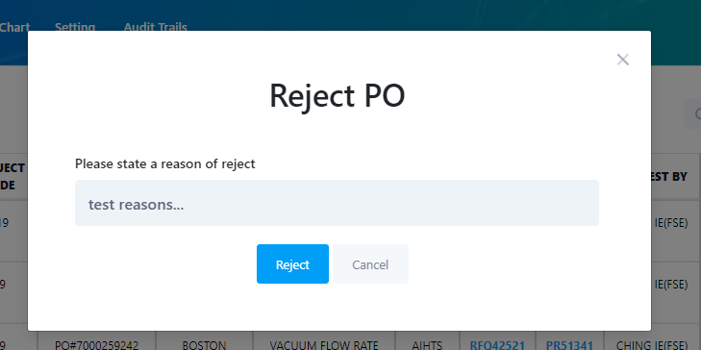

- Once reject, the BOM status will changed to ‘PO Reject’. The RFQ and PR are now available for editing again.
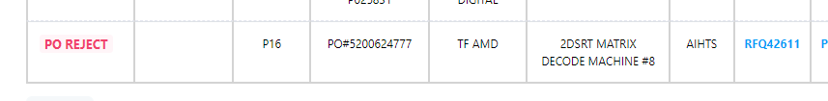

6.1.2 Delete:
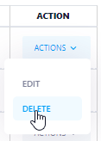
  - This action will delete the uploaded PO file and revert the status to PR Approved stage. This action will allow user to re-submit the PO again.
  - This will not delete the whole BOM.

6.2 PO History tab
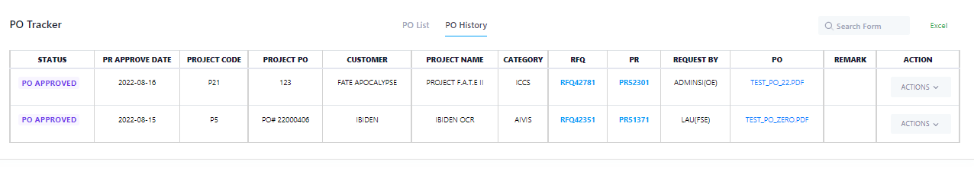
- This tab is only can be access by Buyer user.
- In this tab will only show all records with status ‘PO Approved’.
- Buyer user can edit the record by click on the ‘Edit’ button.
- Buyer user can revert the BOM’s status in this page. By click on the ‘Delete’ button.
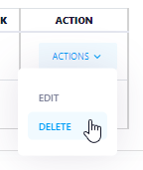
- Note that this will not delete the whole BOM. This action will delete the uploaded PO file and revert the status to PR Approved stage. This action will allow normal user to re-submit the PO again.

6.2.1 Export Excel
- User can export the data to excel by click on the Excel button at the top-right corner of the page.
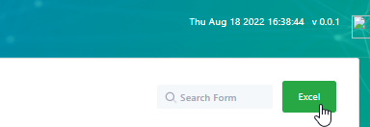

- User can either export all data or export by date range. Leave the textbox blank if wish to export all records. 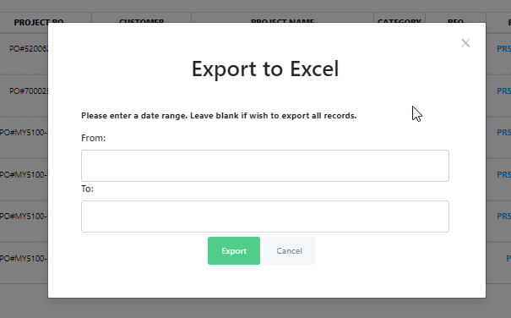
- Click ‘Export’ to start export action.

7. Receiving Tracker
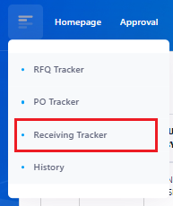
This page will show all PO with status ‘PO Approved’, ‘Item Received’ and ‘Item Issued Out’.
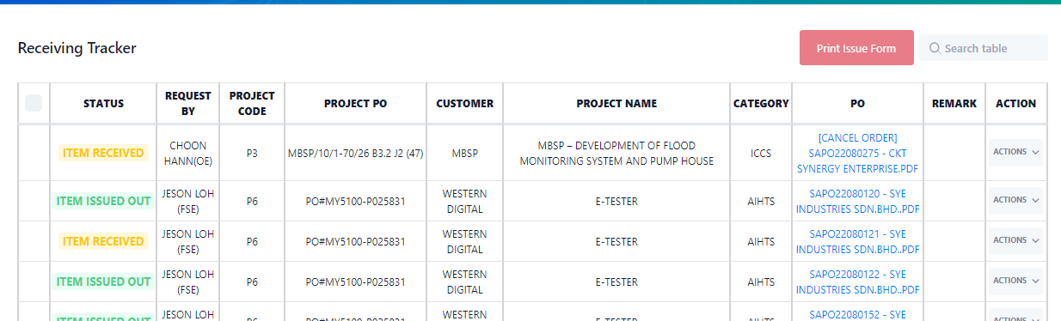

Note that this page will only list by PO. To view the items inside PO, click on the ‘Action’ button at the right side, then click ‘View’.
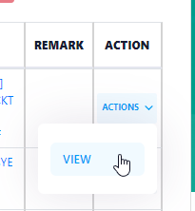

User can generate Material Issue Form by select multiple PO. Check on the checkbox then click the ‘Print Issue Form’ button.
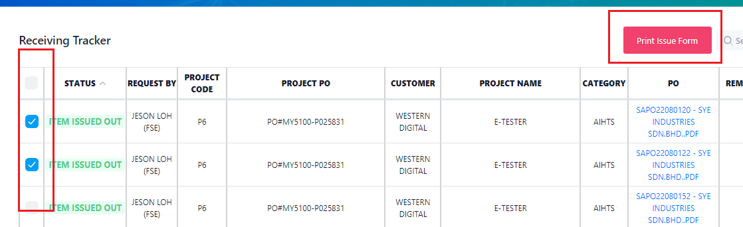

Only PO with ‘Item Issued Out’ status could generate Material Issue Form. For those PO that already generated the form CANNOT be generate again. In this case, the checkbox will not appear.

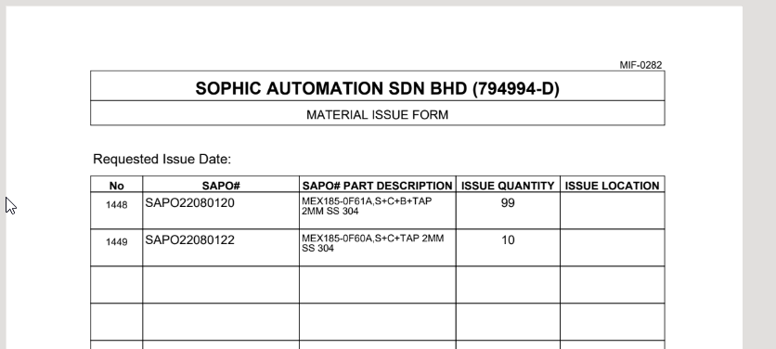
Material Issue Form will be generated on the browser new tab. User can review the form before print it out.

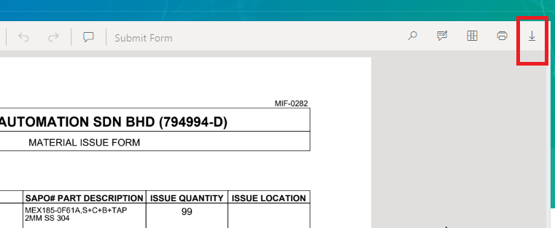
User can download the form as PDF format and print it out by click on the button above.

Alternatively, user can generate the Material Issue form inside the item listing page. Click on the ‘View’ button to view all items in the particular PO.

7.2 Receiving Tracker – Item Listing Page
In the item listing page, user can upload DO, Invoice and GRN respectively.
User can perform the Receiving action and Issue Out action in this page.
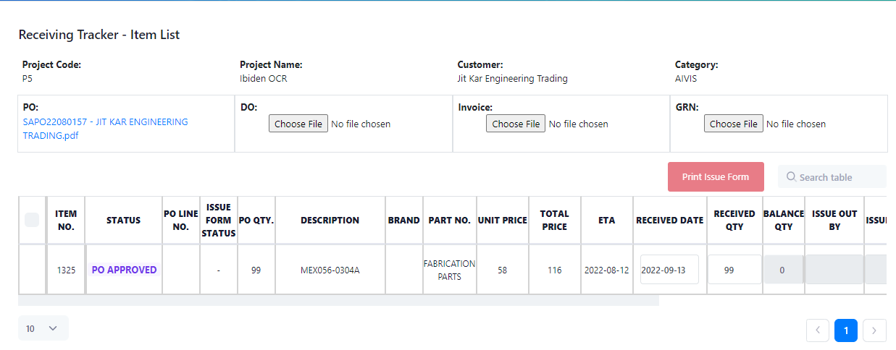

7.2.1 Normal Flow

7.2.1.1 Status: PO Approved -> Item Received

Status PO Approved means the item is waiting to be received. Once the item has arrived, user could enter the Received Date and Received Qty.

User can upload DO and Invoice by click on the ‘Choose File’ button. Click the ‘X’ button to removed selected file.
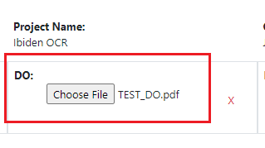
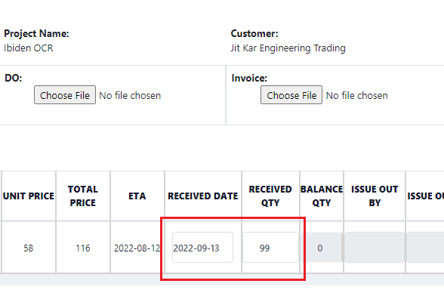
Note that by default, Received Date will auto filled with current date. Received Qty will auto fill with PO Quantity. User can adjust the value manually.
After done, click on the ‘Save’ button to save.
DO and Invoice are required before the item could change the status from ‘PO Approved’ to ‘Item Received’ status.

Summary: upload DO and Invoice, then fill in Received Date and Received Qty.

7.1.1.2 Item Received -> Item Issued Out
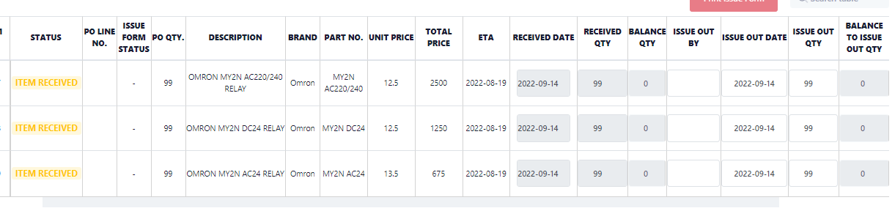
Note that by default, Issue Out Date will auto fill with current date. Issue Out Qty will auto fill with Received Quantity. User can adjust the value manually.
Click on Issue Out By column to choose the PIC.
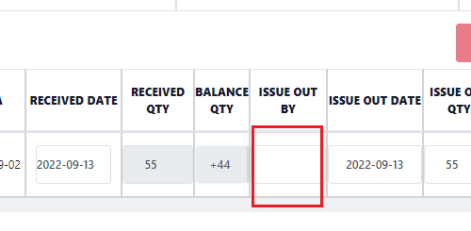

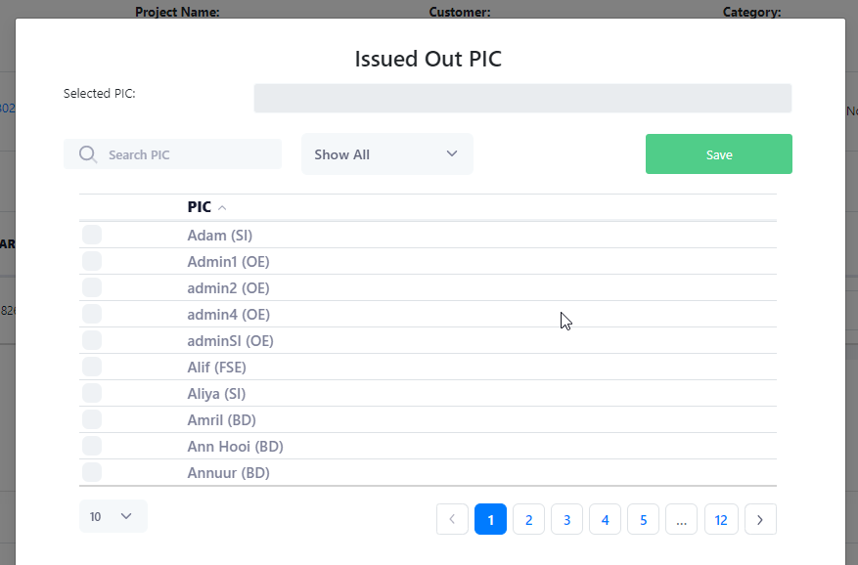
*Only one PIC is allowed.
Summary: Once Issue Out Date, Issue Out Qty and Issue Out By are filled in, click on ‘Save’ button and the item status will change to ‘Item Issue Out’.

7.1.1.3 Item Issued Out -> Completed

The last step is to upload the GRN. Once the GRN is uploaded the item in ‘Item Issued Out’ status with all quantity received and issued out will change to ‘Completed’ status.
Completed Item will be showed in History page and will removed from Receiving Tracker page.

7.1.2 Partial Received
System is now support partial received scenario.
User will need to upload DO and Invoice, then enter the quantity of the item received.
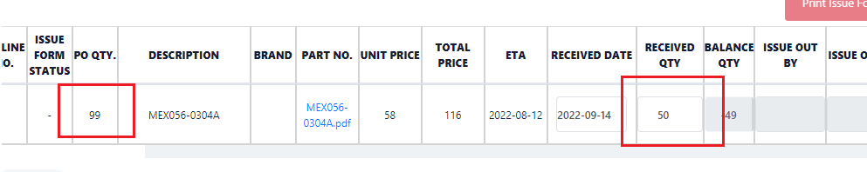
If PO quantity is 99 and item received is 50, just enter Received quantity 50 and click ‘Save’ button.
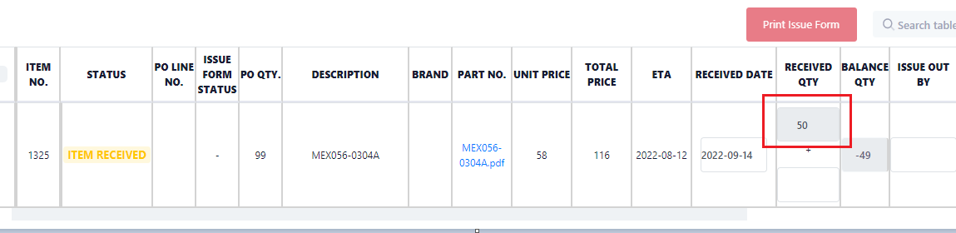
There will be two textbox show in Received Qty column. The textbox on top indicate the quantity received. User can add more quantity in the textbox at the bottom once the next batch of item is received. In current state, user can perform item issue out too.

7.1.3 Partial Item Issue Out
When issue out the item partially, user need to enter the ‘Issue Out By’, ‘Issue Out Date’ and ‘Issue Out Quantity’. By default system will auto fill the Issue Out quantity with current Item Received quantity.
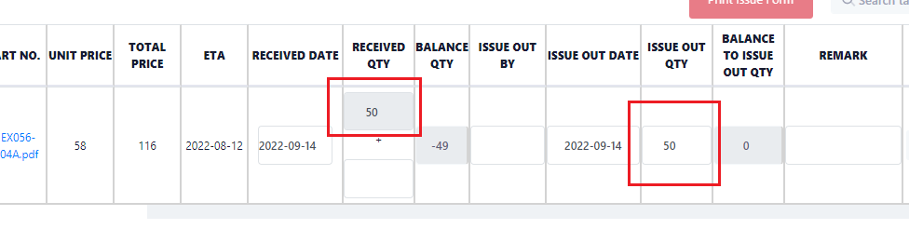
User can adjust the Issue Out quantity manually. Click ‘Save’ button to save the record.

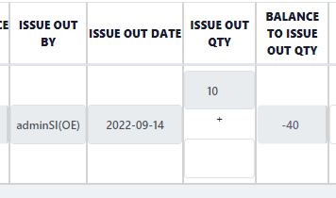
For example only 10 of 50 items is issued out, then the top textbox will indicate the quantity that already issued out.
In current state, user can proceed to generate Material Issue Form for this record first.
Note that before generate the form, remember to save the record first.
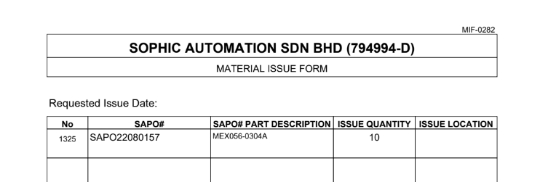
Material Issue Form will automatic set the issued out quantity as 10.
During next round of item issue out, for example issue quantity is 30, when generate Material Issue Form the Issue Quantity will be 30.
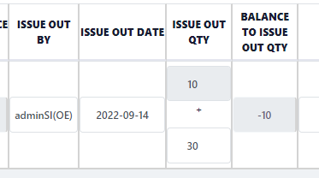
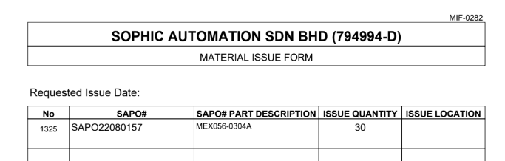

7.1.3.1 Issue Form Status
Once the item is already generate Material Issue Form at least one time, the column ‘Issue Form Status’ will indicate the status whether the form is being generated.
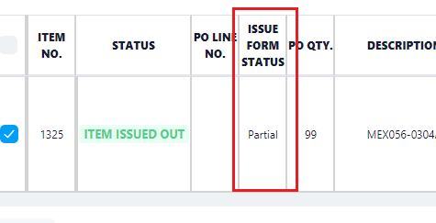
Issue Form Status list:
- Never generate Material Issue Form : ‘-‘
- Generated Material Issue Form with Partial Issue Out quantity: ‘Partial’
- Generated Material Issue Form with Full Issue Out quantity: ‘Generated’

8. History Page
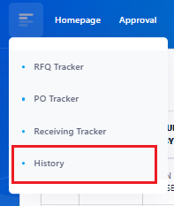
This page is similar to Receiving Page. But will only shows BOM with ‘Completed’ status. Once the BOM is completed, no edit or delete action is allowed.
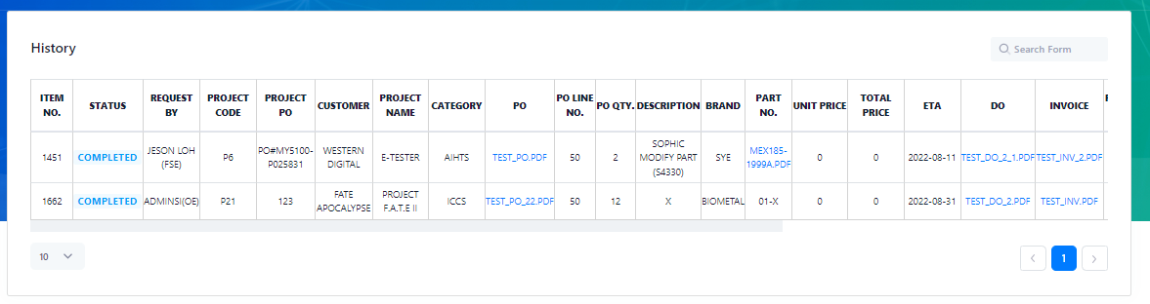
- User can view the PO, Part Number, DO, Invoice and GRN pdf document by click on the file name.

